CAP 6629: Reinforcement Learning
Imtiyaz Mohammed
Z23749265 Assignment 1
Consider the 10-armed bandit problem we discussed in the class. Assume we apply the ε-greedy method to choose the actions. Please compare the results (bandit average score) for ε=0.4, ε=0.1, and ε=0.01.
Co-lab Link:
Code:
I choose to modify the existing code and change the epsilon values and do necessary modifications.
#Uncomment and run this line if ray is not installed
!pip install ray
import sys
import numpy as np
import ray
import time
import copy

import matplotlib.pyplot as plt
from collections import deque
np.random.seed(501)
class BanditProblem():
def __init__(self, arms, stationary=True):
self.stationary = stationary
self.bandit_arms_values = np.random.normal(loc=0.0, scale=1.0, size=arms) # get random mean values for each arm
self.optimal_action_index = np.argmax(self.bandit_arms_values)

def draw_from_arm(self, arm_index):
chose_optimal = 1 if arm_index == self.optimal_action_index else 0
reward = np.random.normal(loc=self.bandit_arms_values[arm_index], scale=1.0) # draw from distribution of each arm

return reward, chose_optimal

def step_arm_values(self):
'''
Step to be called manually in episode loop.
'''
q_star_value_shift = np.random.normal(loc=0.0, scale=0.01, size=len(self.bandit_arms_values))
self.bandit_arms_values += q_star_value_shift
self.optimal_action_index = np.argmax(self.bandit_arms_values)

def reset(self):
'''Reuse the same bandit problem object as a clean slate, instead of creating a new object'''
self.bandit_arms_values = np.zeros(shape=len(self.bandit_arms_values))
self.optimal_action_index = 0
class EpsilonGreedyAgent():
def __init__(self, epsilon, bandit_problem, alpha=0.1, update_type="incremental"):
self.epsilon = epsilon
self.alpha = alpha
self.problem = bandit_problem
self.update_type = update_type

self.arm_qs = np.zeros(len(bandit_problem.bandit_arms_values))
self.arm_ns = np.zeros(len(bandit_problem.bandit_arms_values))

def choose_action(self):
if np.random.rand() > self.epsilon:
# greedily pull best arm
choice = np.argmax(self.arm_qs)
else:
# explore pull any random arm (still a chance to pull best arm too)
choice = np.random.randint(0, len(self.arm_qs))

self.arm_ns[choice] += 1

reward, optimal = self.problem.draw_from_arm(choice)

if self.update_type == "incremental":
self.update_estimate_incremental(choice, reward)
elif self.update_type == "weighted":
print('No such update type! Proceeding to use incremental update')
self.update_estimate_incremental(choice, reward)

return reward, optimal

def update_estimate_incremental(self, choice_index, reward):
self.arm_qs[choice_index] = self.arm_qs[choice_index] + (1/self.arm_ns[choice_index])*(reward - self.arm_qs[choice_index])
@ray.remote
def run_bandit_episode(steps=10000, stationary=False):
problem = BanditProblem(arms=10, stationary=stationary)
agents = []
# Epsilon values to compare
epsilons = [0.4, 0.1, 0.01]
for epsilon in epsilons:
incremental_update_agent = EpsilonGreedyAgent(epsilon=epsilon, bandit_problem=problem, update_type="incremental")
agents.append(incremental_update_agent)

# two rows for each agent: score and optimal_choice
results = np.zeros((2*len(agents), steps))

for step in range(steps):
for i_agent, agent in enumerate(agents):
reward, optimal = agent.choose_action()
results[i_agent*2, step] = reward
results[(i_agent*2)+1, step] = optimal
if not stationary:
problem.step_arm_values()
return results

def plot_rewards_and_optimals(results, num_agents, agent_names=[], title=""):

num_agents = len(agent_names)
aggregates_score = []
aggregates_optim = []

for i_agent in range(0, num_agents):
agent_rewards_index = i_agent*2
agent_optims_index = (i_agent*2)+1

agent_agg_score = np.mean(results[:, agent_rewards_index, :], axis=0)
agent_agg_choice = np.mean(results[:, agent_optims_index, :], axis=0)

aggregates_score.append(agent_agg_score)
aggregates_optim.append(agent_agg_choice)

fig, (ax1, ax2) = plt.subplots(1, 2)
fig.set_figheight(5)
fig.set_figwidth(15)

ax1.set_title("Bandit Avg. Score")
for i in range(0, num_agents):
ax1.plot(aggregates_score[i], label=agent_names[i])

ax2.set_title("Avg. optimal choice selected %")
for i in range(0, num_agents):
ax2.plot(aggregates_optim[i], label=agent_names[i])

fig.suptitle(title)
plt.legend()
plt.show()
runs = 2000 # run 2000 times and average over these runs, set this lower for increased speed (two hundred should be enough)
steps = 15000 # run each episode for 5000 steps, lower this for increased speed (5000 should be enough)

futures = [run_bandit_episode.remote(steps=steps, stationary=True) for i in range(0, runs)]

tic = time.perf_counter()
stationary_results = ray.get(futures)
toc = time.perf_counter()

print(f"Whole experiment took: {toc - tic} seconds")

print(len(stationary_results))

stationary_results = np.array(stationary_results)
stationary_results.shape
plot_rewards_and_optimals(results=stationary_results, num_agents=3, agent_names=["incremental e-greedy e = 0.4", "incremental e-greedy e = 0.1", "incremental e-greedy e = 0.01"])
Output:
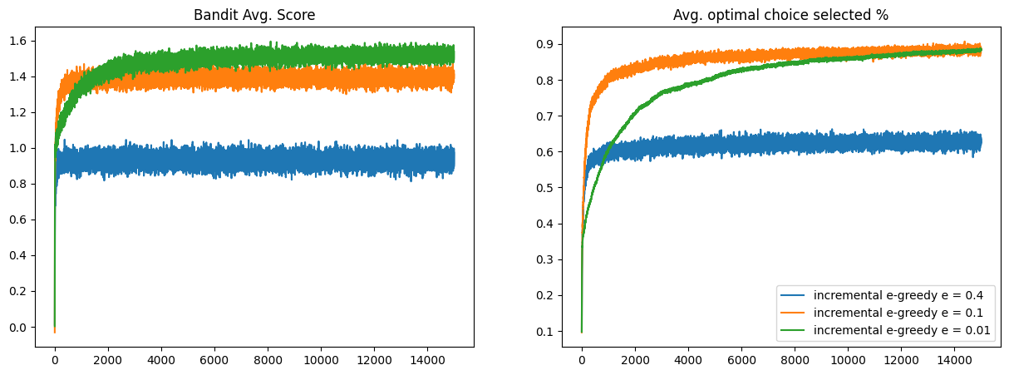
The place I changed the epsilon value in the code I highlighted the code in Teal colour, also providing the code for the epsilon here as well.
# Epsilon values to compare
epsilons = [0.4, 0.1, 0.01]
for epsilon in epsilons:
incremental_update_agent = EpsilonGreedyAgent(epsilon=epsilon, bandit_problem=problem, update_type="incremental")

Analysis and Comparison of Epsilon-Greedy Method
- The ε-greedy method is based on a trade-off between exploration for new rewards and exploitation to get high rewards.
- The ε parameter controls as higher values of ε encourage more exploration, while lower values Favor exploitation.
- Impact of Different ε (Epsilon Values) such as for ε value for 0.4 which had high exploration scenario and the algorithm does not miss the chance on high reward arms, in the act it slows down the convergence towards the optimal arm as it constantly tries new options. The average reward may be more unstable, as frequent exploration can introduce unsatisfactory choices into the action selection. ε value for 0.1 which is a balanced method between exploration and exploitation. but mostly exploits the best-known arm. Which leads to a more stable reward accumulation, as the algorithm begins to converge on the optimal arm faster while still gathering enough information from other arms to ensure that the ideal action is chosen. ε value for 0.01, In this scenario with low exploration, the algorithm primarily depends on the arm that is currently the most well-known. Faster convergence toward the optimal arm is made possible by this, but if it does not adequately explore to identify alternative, possibly superior arms, it may become trapped in local optima. If better arms are missed because there hasn't been enough exploration, the average reward may rise more quickly at first before decreasing
- Graphical Comparison: For ε = 0.4, a slower increase in average reward due to more exploration. For ε = 0.1, a moderate rate of increase and a stable average reward as the method strikes a balance. For ε = 0.01, a fast initial increase in average reward followed by a plateau, indicating that the algorithm quickly settles on an arm but might miss potentially better options due to limited exploration.
Summary:
The algorithm's convergence rate and stability towards the optimal arm are affected by the value of ε. Smaller ε values (e.g., 0.01) may result in faster short-term gains but run the risk of missing out on better long-term rewards. Larger ε values (e.g., 0.4) ensure thorough exploration but at the cost of slower exploitation. A value in the middle, like 0.1, offers a decent compromise between these two extremes.
The analysis is intended to clarify the variations in performance for every value of ε. This interpretation of the data from your plotted comparison figure can also be used to highlight the behaviour of each curve in relation to the exploration-exploitation trade-off.

